**PuTTy**

Using PuTTy Key Generator, generate .ppk file to connect virtual machine server:  
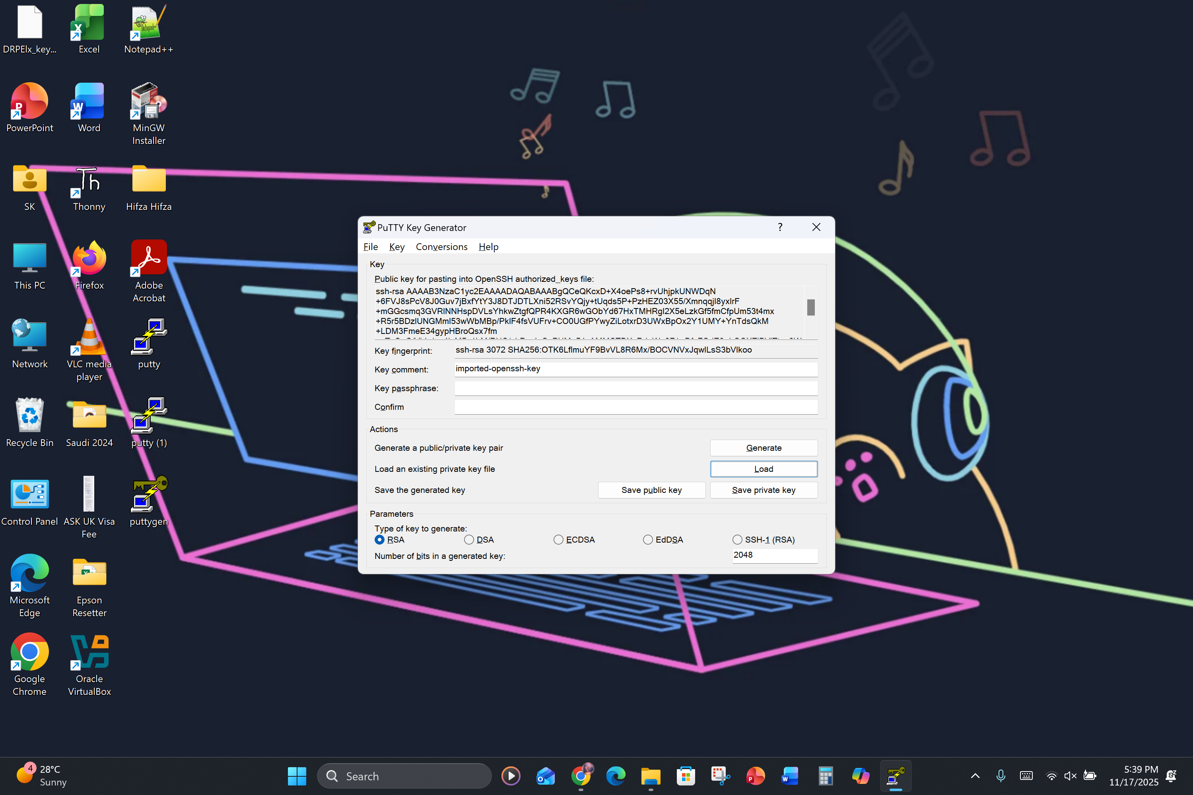

Save the .ppk file onto the computer:  
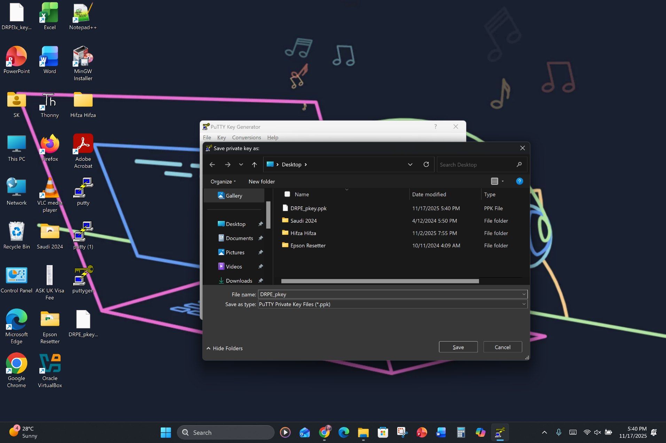

Using PuTTy Configuration, add the details such as username@ip_adress:  
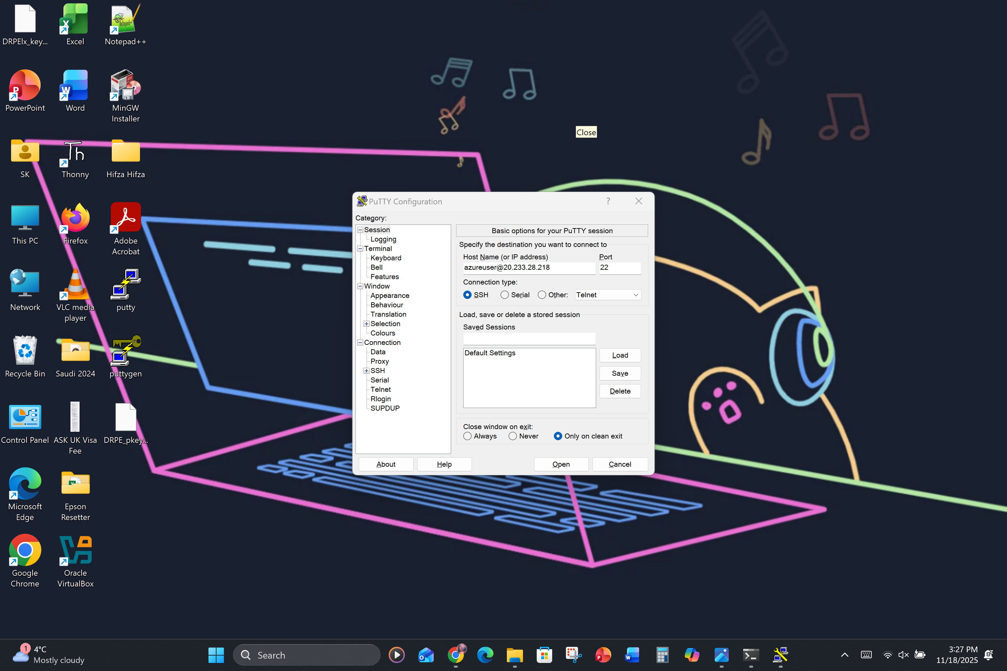

And in Authorization Credentials, write the .ppk file directory.  
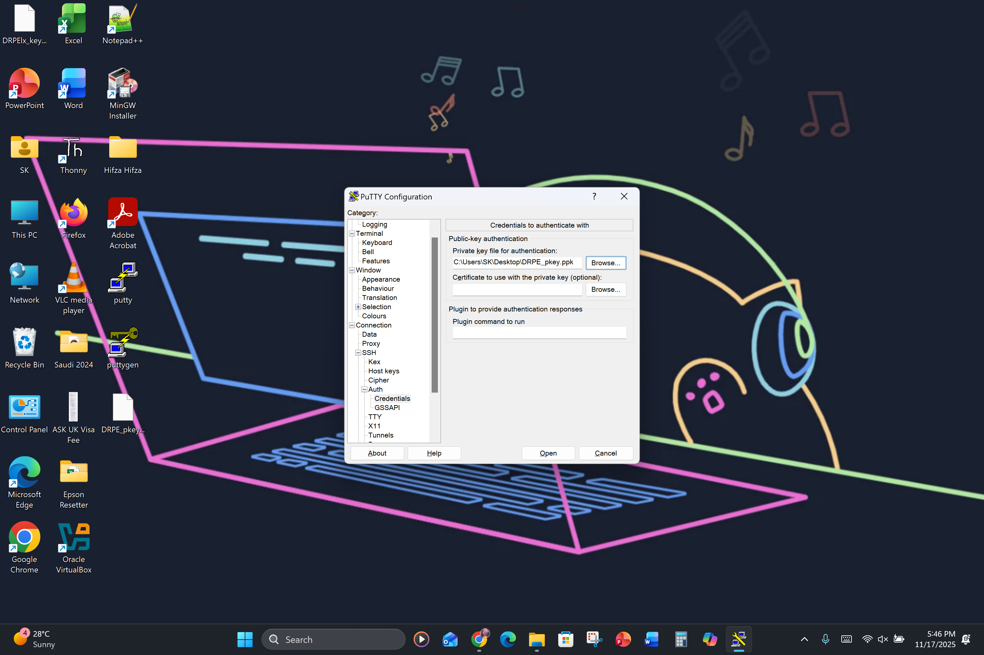

Once the above two details have been entered, press Open to connect:  
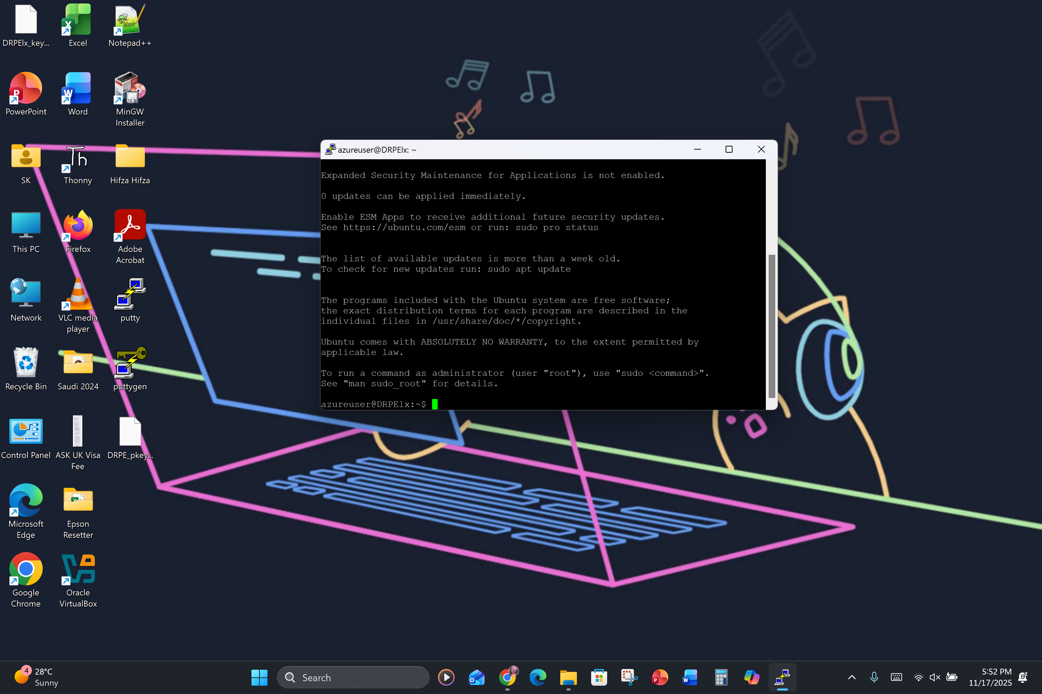

Checking whether apache2 is installed and running:  
